Important Deadlines:

|  |  |
| --- | --- |
| Item | Due Date |
| Build Truss | Done by the end of Week 12 |
| Testing Truss | Week 13 |
| Written and Oral Report | Week 14 |

Individual Truss Bridge Designs:

Kayla’s Design: Max Load- 327.8 lbs Length- 61.25 in Ratio-5.35

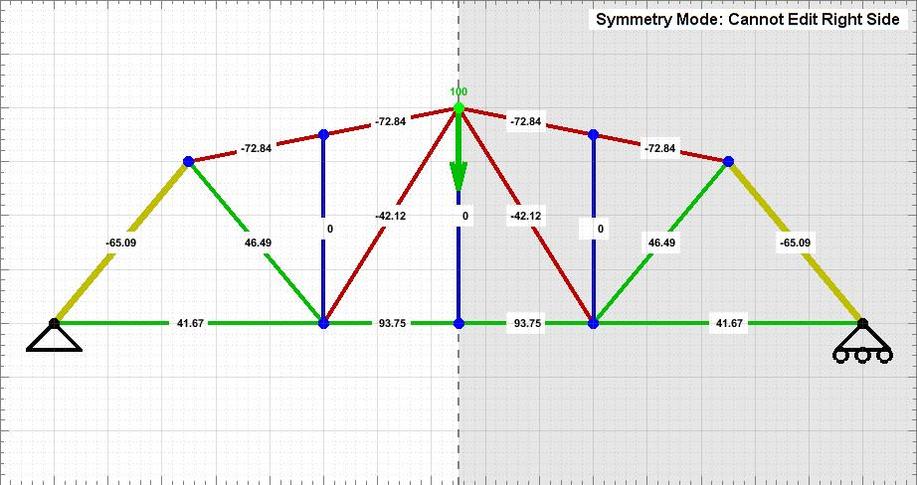

Trevor’s Design: Max Load- 355lbs Length- 62.17 in Ratio-5.71

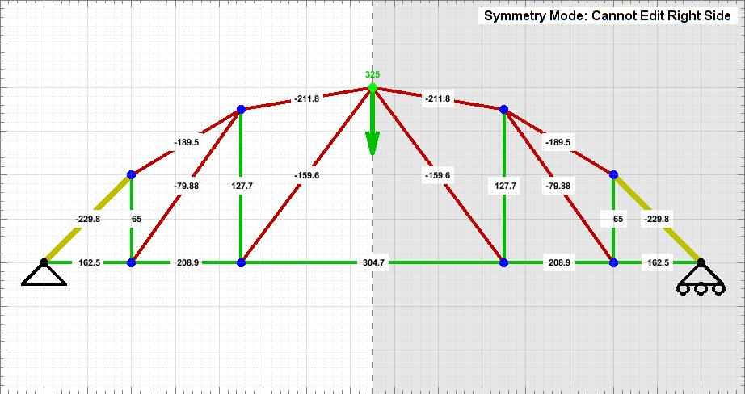

10/24/2018

Class Tasks:

Agree on a Group Design

Sketch Design

Practice Soldering

Group Design: Max Load- 346.2 lbs Length- 56.06 in Ratio- 6.18

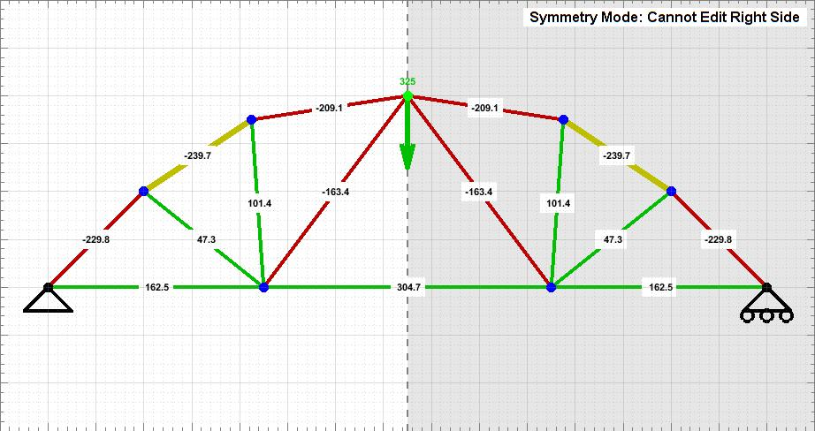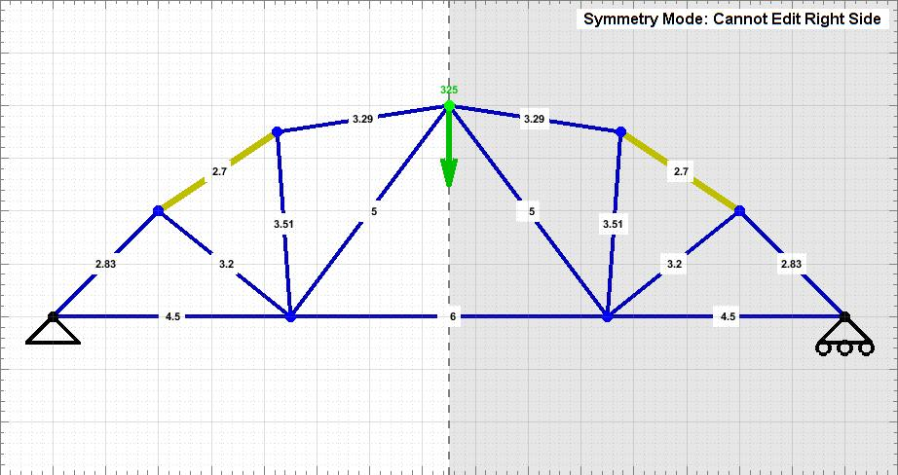

11/7/18 - Constructing Truss

Something we didn’t think about is how the lengths were supposed to come together so after using calipers to check sizes and sanding down to the specific lengths, we laid out the pieces and they didn’t fit together on our fills size sketch, it didn’t follow the coordinates. This made us resize and sand members 2, 4, 5, 7, 8, 9, 10, 11, 12, and 13. Now all of our pieces fit and are prepared to solder.

Advice on written Report- Look at how readable, how clear, how much info straightforward, good report ,don’t worry about a prestigious journal, flow like a story, it’s a conversation

-Writing guide to pictures

-Abstract- to tell you, if you read this this is what you’ll learn

-guided tour through project

-how well can you tell the story that you did and flow through what you did

-due last day of class

Extra Credit Project

-MatLab Project

11/14/18

First test: 300.2 lbs

|  |  |
| --- | --- |
| Work Breakdown | |
| Truss Designs | Individual Designs:  Trevor Dawideit  Kayla Gorrell  Darren George  Final Design:  Trevor Dawideit  Sketch-  Kayla Gorrell |
| Fabrication | Cut and Sand-  Kayla Gorrell  Trevor Dawideit  Soldering-  Darren George  Jonathan Joshua |
| Oral Report | Objective-  Darren George  Requirements-  Jonathan Joshua  Design-  Kayla Gorrell  Testing/Final Evaluation-  Trevor Dawideit |
| Written Report | Abstract/Title Page/ToC-  Kayla Gorrell  Introduction-  Darren George  Jonathan Joshua  Discussion-  Kayla Gorrell  Trevor Dawideit  Conclusion-  Trevor Dawideit |
| Project Management | Kayla Gorrell |